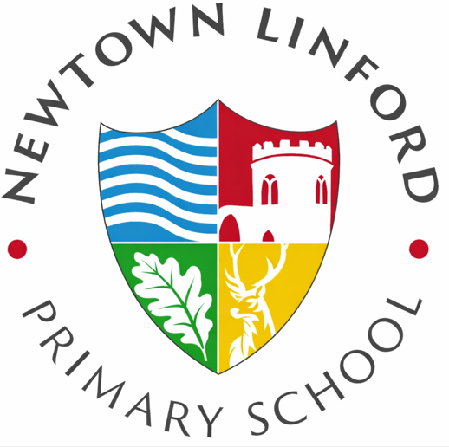
Newtown Linford Primary School

School Uniform Policy

Principles
Our aim is to have pupils dress with a school identity in a smart, affordable and practical way, which conforms to standards of decency and safety and enables all pupils to be seen and therefore treated equally. The school uniform shows that pupils belong to our school community and is to be worn with pride. School Uniform is a requirement for being part of our school community.

The Local Advisory Body expects all parents who accept a place at Newtown Linford Primary School to comply with school uniform standards.

** This policy should be read in conjunction with the school uniform list

Aims
Our policy is based on the belief that a school uniform:

- Promotes a sense of pride in the school
- Engenders a feeling of belonging
- Identifies the children with the school
- Is not distracting in class (as fashion clothing might be)
- Makes children feel equal to one another in terms of appearance
- Reflects the sense of community that the school takes pride in
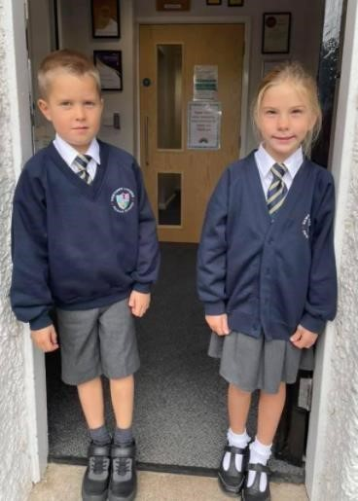
- Is regarded as suitable, and good value for money, by most parents Has been designed with health and safety in mind

All children (EYFS-Year 6) need:

- Navy sweatshirt or cardigan with school logo
- Plain white collared shirt, not a polo
- Grey skirt, pinafore, knee length shorts or trousers (no jeans, fashion trousers, jeggings, leggings, combat trousers with zips or side pockets or any items with logos)
- Summer navy and white gingham dress (optional)
- White or grey socks or tights
- Tie (yellow & navy) *
- Plain black, navy or brown shoes or boots (no trainers or UGG type boots)
- Simple navy/white or plain headbands/clips (no fashion headbands with additional items such as flowers or bows)
*In hot weather ties may be removed at the Headteacher’s discretion.

PE Kit:
- Black or navy shorts
- Navy short sleeved top with school logo
- Black or navy tracksuit bottoms
- Navy hooded sweatshirt with school logo (optional) or navy/black without school logo
- Plimsolls for indoor activities
- Trainers for outdoor activities

Our branded uniform is supplied by Uniform Direct. Please order directly from them via their website. Ties and woolly hats are available from the School Office. Non-branded uniform can be bought at Uniform Direct or any other shop of your choice. (A wide variety of supermarkets and chain stores supply the uniform items which don’t require a logo and are in line with our school’s uniforms policy).

Pre-loved uniform and shoe bank

The PTA organises a pre-loved school uniform service and shoe bank for families to access good quality pre-loved school items. Please make any requests through the PTA Facebook page
(@NewtownLinfordPrimarySchoolPTA), via the Class WhatsApp groups or enquire at the school office.
Families who are facing financial difficulties will be donated items from this stock at the discretion of the Head teacher.

Jewellery, Make –Up and Headgear

- On health and safety grounds, we do not allow children to wear jewellery in our school. The exceptions to this rule are plain earring studs in pierced ears, and small objects of religious significance. We ask the children to remove these objects during PE, children have their ears pierced at the beginning of the 6-week summer holidays to enable them to do this. If this is not the case the child must cover the earrings themselves with plasters brought from home.
- We do not allow children to wear make-up or nail varnish for school. Children wearing either will be asked to remove it for the next school day and a note will go home to parents. If a child returns the next day still wearing nail varnish or make up they will be asked to remove it, using wipes or remover supplied by school.
- We do not allow headwear to be worn during class time or inside school buildings, except for religious or medical reasons. Plain hats can be worn outside for protection from the sun in the summer and warmth in the winter.
- For reasons of health and safety sunglasses should not be worn at school except for medical reasons. This should be put into writing to the Headteacher.
- We do not allow the use of smart watches in school. However, a small wrist/sports watch is acceptable.

Haircuts

- Long hair should be worn up during the school day and for all PE lessons
- The school does not permit children to have haircuts that could serve as a distraction to other children. Please check with school first if you are unsure.

Footwear

The school wants all children to grow into healthy adults. We believe that it is dangerous for children to wear shoes with platform soles or high heels in school, so we do not allow this for the same reason sandals are also not permitted. Plain black trainers with no logos may be worn as long as children have an alternative pair to wear for PE for hygiene reasons. In the Winter, children may wear smart plain black boots (not Ugg type).

Mobile phones

Mobile phones in school are not permitted. However, school recognises that there may be some individual circumstances/occasions when parents may wish their child to bring a phone to school. In this situation parents should inform school of their request and on arrival at school the phone should be handed directly to the school office in a named bag/container for safe keeping.

Smart Watches
The school does not permit any pupils in school to wear a smart watch. We define a smart watch as a wearable electronic device designed to be worn on the wrist that connects to a smartphone or operates independently, and is capable of functions beyond timekeeping. These functions may include:
- Sending and receiving calls, messages, or notifications
- Accessing the internet or apps
- Recording audio, images, or video
- Tracking location (GPS)
- Monitoring health or fitness data
For the purposes of this policy, any watch-like device with communication, recording, or internet-enabled capabilities is considered a smartwatch. If a child comes to school wearing a smartwatch they will be asked to remove it and hand it in to the office for the school day.

Role of Class Teachers and Staff

- Set a good example in terms of dress
- Remember that in our respective roles we serve the local community as a set of professionals
- To remind children to wear school uniform and write a note in Home School Books if children are not wearing correct uniform. If children are still not wearing correct school uniform the following day Class Teachers are to refer it to the Headteacher

Non-compliance with school uniform is seen as a breach of school rules.
Pupils will be reminded of the uniform policy and asked to remove items such as nail varnish, or not wear specific items the next day.

Role of the Headteacher

- The Headteacher is to ensure that pupils comply with this uniform policy as agreed by the governing body
- The Headteacher has duty to enforce the school uniform throughout the school community, as part of the maintenance of day-to-day discipline in the school
- The Headteacher will speak to the parents of children who persistently do not wear the correct uniform
Periodic uniform checks will be carried out by the Headteacher. If a child’s uniform does not meet the standards outlined in this policy parents/carers will be informed by letter which will identify the reason(s) and there will then be a second check a few days later.

If pupils do not comply with the uniform policy the following day, the Headteacher may use the following consequences

- Confiscation of banned item(s) for collection by parent/carer
- Providing spare uniform to be worn for the day if it is apparent that the child is refusing to comply with uniform standards
- Removing make-up using wipes supplied by the school
- Removing nail varnish using remover supplied by the school
- Parents contacted and asked to bring in the appropriate clothing
- Persistent breaches of School Uniform Policy will lead to missed break and lunchtimes and ultimately internal seclusion

Role of Parents/Guardians

- To ensure that their child/children adhere to the school’s uniform policy
- Ensure that their child children come to school in uniform everyday unless there are special circumstances such as non-uniform days
- To inform the class teacher/Headteacher if there is a genuine reason for not wearing an item of uniform outlining the reason and agree a date when the pupil will be wearing the correct uniform
- If any parent would like the school to modify the uniform policy, they should make representation, in the first instance, to the Headteacher. The school welcomes children from all backgrounds and faith communities. If there are serious reasons, e.g. religious objections, why parents and carers want their child to wear clothes that differ from school uniform, the school will look sympathetically at such requests. Similarly, should an item of school uniform prove problematic for a pupil with disabilities, parents and carers are invited to draw this to the attention of the Headteacher. The school does not treat pupils with disabilities unfavourably.

Role of Local Advisory Board

- To support the Headteacher in implementing the school uniform policy.
- To consider all representations from parents and carers regarding this policy as in laid out in the Complaints Policy and liaise with the Headteacher to ensure that the policy is implemented fairly and with sensitivity.
- To ensure that the school uniform meets all national regulations concerning equal opportunities, and that our school uniform policy is consistent with our policy on equal opportunities.
- To ensure that school uniform policy helps children to dress sensibly, in clothing that is hardwearing, safe and practical.
- Seek views of parents and carers, to be sure that they agree with the policy, and support it.
To consider, with the Headteacher, any requests from parents or carers for individual children to have special dispensations.
- Require the Headteacher to report to the governors on the way in which policy is being implemented.

Racial Equality and Equal Opportunities

All children have equal access to wearing school uniform regardless of their culture, race, religion, gender, disability or ability. We ensure that the set uniform respects other policies such as Race relations, sex discrimination and allows for individual circumstances of all groups and individuals. Newtown Linford Primary School is committed to creating a positive climate that will enable everyone to work free from racial intimidation and harassment and achieve their full potential.

Monitoring and Review

This policy will be reviewed by the governing body every two years, or earlier if considered necessary.
This policy is based upon the Department for Education’s upcoming statutory guidance on school uniforms (September 2026).

