Newtown Linford Primary School
Remote Education Information for Parents
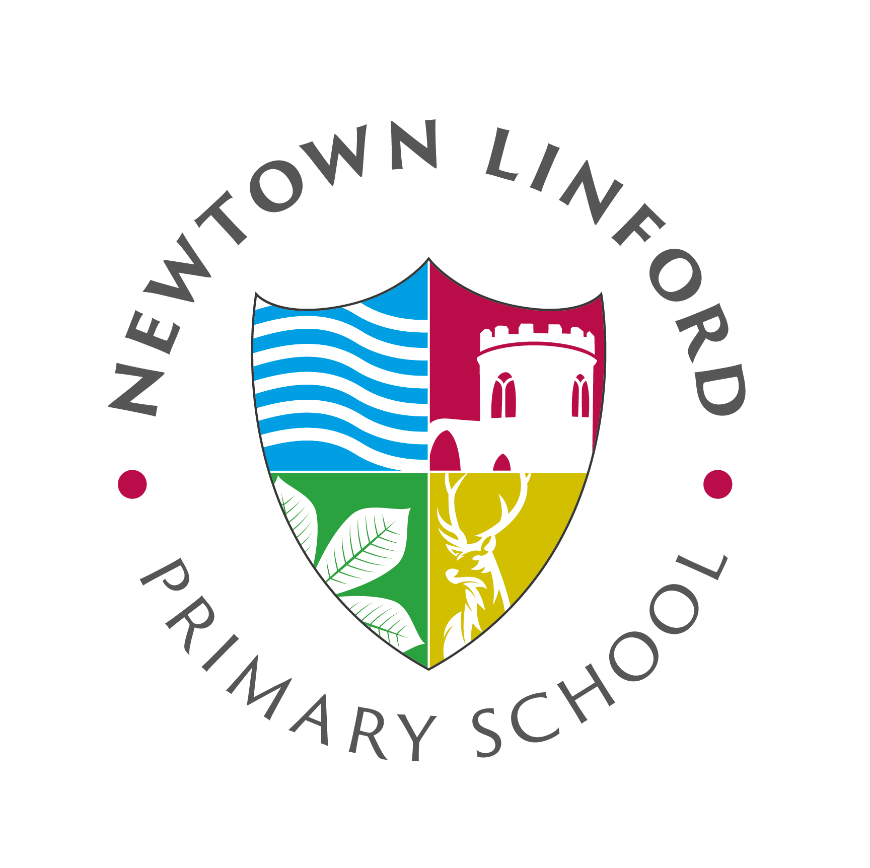

Remote education provision: information for parents
This information is intended to provide clarity and transparency to pupils and parents or carers about what to expect from remote education where national or local restrictions require entire cohorts (or bubbles) to remain at home.
For details of what to expect where individual pupils are self-isolating, please see the final section of this page.

The remote curriculum: what is taught to pupils at home
A pupil’s first day or two of being educated remotely might look different from our standard approach, while we take all necessary actions to prepare for a longer period of remote teaching.

What should my child expect from immediate remote education in the first day or two of pupils being sent home?
On the first day of remote education, teachers will provide tasks via Teams and the school website for your child to complete.

Following the first few days of remote education, will my child be taught broadly the same curriculum as they would if they were in school?
We teach the same curriculum remotely as we do in school wherever possible and appropriate. However, we have needed to make some adaptations in some subjects. For example, design and technology in which families may not have all the equipment required.

Remote teaching and study time each day

How long can I expect work set by the school to take my child each day?
We expect that remote education (including remote teaching and independent work) will take pupils broadly the following number of hours each day:
Key Stage 1 | Four hours
Key Stage 2 | Four to five hours

Accessing remote education

How will my child access any online remote education you are providing?
Your child will access remote learning via Teams. They will have received their username and password. If you have any difficulties accessing Teams or the calendar for virtual sessions, please contact the school office for support.

If my child does not have digital or online access at home, how will you support them to access remote education?
We recognise that some pupils may not have suitable online access at home. We take the following approaches to support those pupils to access remote education:
If you require a device please let the school know and we will identify how we can support.
If you require a device to enable an internet connection please contact Mrs Cox in the school office. She will be able to apply for a 4G router on your behalf.
Teachers have designed tasks that should not require printing, however if you do need resources printing and do not have the facility to do this at home please contact the school office and we will arrange printing and collection.
Work should be submitted via the assignment tab on Teams. If you do not have online access you can submit and exercise book when it has been completed. This will be quarantined in the office before being reviewed by the class teacher.

How will my child be taught remotely?
We use a combination of the following approaches to teach pupils remotely:
- daily live teaching (online lessons)
- recorded teaching (e.g. Oak National Academy lessons, video/audio recordings made by teachers)
- printed paper packs produced by teachers (e.g. workbooks, worksheets)
- textbooks and reading books pupils have at home
- commercially available websites supporting the teaching of specific subjects or areas, including video clips or sequences

Engagement and feedback

What are your expectations for my child’s engagement and the support that we as parents and carers should provide at home?
We expect children to attend daily live sessions wherever possible. If your child is unable to attend due to illness or your work commitments, please can you let us know by emailing the school office. We will be keeping a record of attendance.

If your child is unable to join the live sessions we ask that you complete and tasks set at another convenient time. If your child has not completed tasks because they are ill, do not worry about completing all missed work.

In order to support families we are providing at least two live lessons a day, with some days there being more than this. When there are no live lessons in an afternoon, pre-recorded content is made available to the children. Children in the majority of year groups should be able to access and engage in these independently. Children in Year R and Year 1 may need support.

How will you check whether my child is engaging with their work and how will I be informed if there are concerns?
We will be completing a daily register for attendance in virtual sessions. If your child has not attended sessions (and we have not been informed of a reason for the absence) or been persistently late we will contact you to discuss this and provide any support required.

Teachers will check work has been submitted through Teams and again we will let you know if work has not been submitted or we have concerns around the work submitted.

Children and parents will also be offered a one to one session with their child’s class teacher in which you can ask any questions or concerns you have.

How will you assess my child’s work and progress?
Feedback can take many forms and may not always mean extensive written comments for individual children. For example, whole-class feedback or quizzes marked automatically via digital platforms are also valid and effective methods, amongst many others. Our approach to feeding back on pupil work is as follows:
Children will receive feedback in the following ways –

- Feedback on completed work submitted to assignments in Teams. Not all work will require feedback but you should expect feedback on a couple of these tasks per week.
- One to one verbal feedback on wider progress and specific support on any areas that require clarification or additional challenge.
- Verbal feedback in daily live lessons is a very important part of the feedback process and this will be why your child’s class teacher asks questions throughout the session or sets short tasks to complete. If your child has not understood the task they can ask for support at the end of the sessions and the teacher or a Learning Support Assistant will try to stay on or arrange another meeting to help.

Additional support for pupils with particular needs

How will you work with me to help my child who needs additional support from adults at home to access remote education?
We recognise that some pupils, for example some pupils with special educational needs and disabilities (SEND), may not be able to access remote education without support from adults at home. We acknowledge the difficulties this may place on families, and we will work with parents and carers to support those pupils in the following ways:
If your child has additional needs and you are struggling with the remote learning please get in touch and we will work with you and your child to support them access learning. This may be through –
- Additional one to one sessions.
- School resources sent home to aid learning.
- Access to online interventions that are personalised for your child.

Remote education for self-isolating pupils
Where individual pupils need to self-isolate but the majority of their peer group remains in school, how remote education is provided will likely differ from the approach for whole groups. This is due to the challenges of teaching pupils both at home and in school.

If my child is not in school because they are self-isolating, how will their remote education differ from the approaches described above?
If your child is required to self-isolate work will be sent to them via the school office. You can then return this work through Teams or in an email to the school office. Feedback will be provided as outlined above, however one to one sessions will be with the Co-Headteachers as opposed to the class teachers.

